Iflow process for Brazil NFe XML sample.

Scope: Create an iflow in CPI that receive the NFe xml AND store one log in CPI for further analysis.

IFLOW DESIGN:

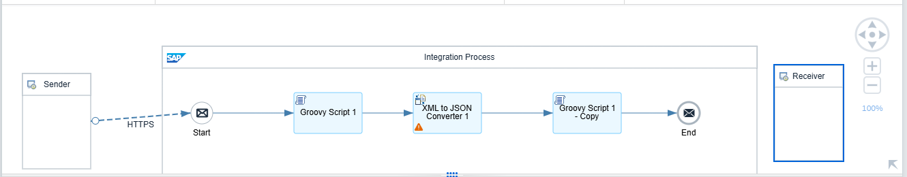

1 – HTTPS Conection

2 – Groovy Script 1

3 – XML To JSON

4 – Groovy Script 1 – Copy

1 - HTTPS Call:

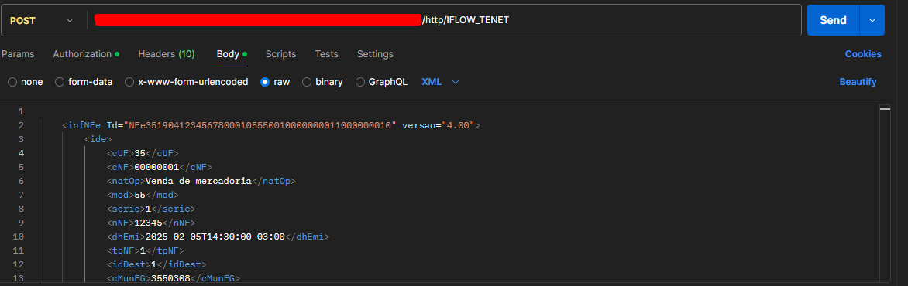

Once integration its created you will have one URL that you can GET, SEND, DELETE accordantly

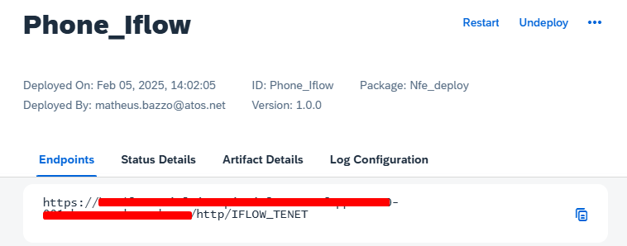

For previous check of XML payload, please check the file “XML_PAYLOAD.TXT”.

2 -Groovy Script:

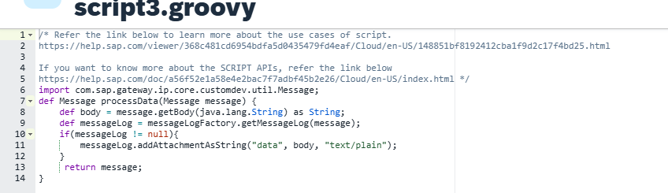

This Groovy script is used in SAP Integration Suite (SAP CPI) to log the message payload. It retrieves the message body as a string and, if logging is enabled (messageLogFactory is available), it attaches the message content as a text/plain attachment named "data" to the message log. Finally, it returns the original message without modifications. For this case, it will generate the XML LOG for the first request.

Data file has the body payload request generated by groovy:

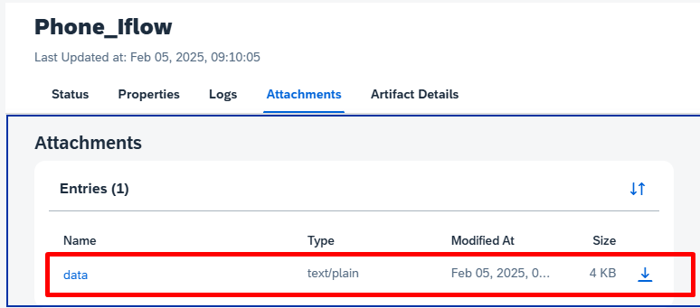

3 – XML to JASON.

CPI has standard ways to convert XML to JASON, for this scenario I’m using standard mapping.

Conversion example:

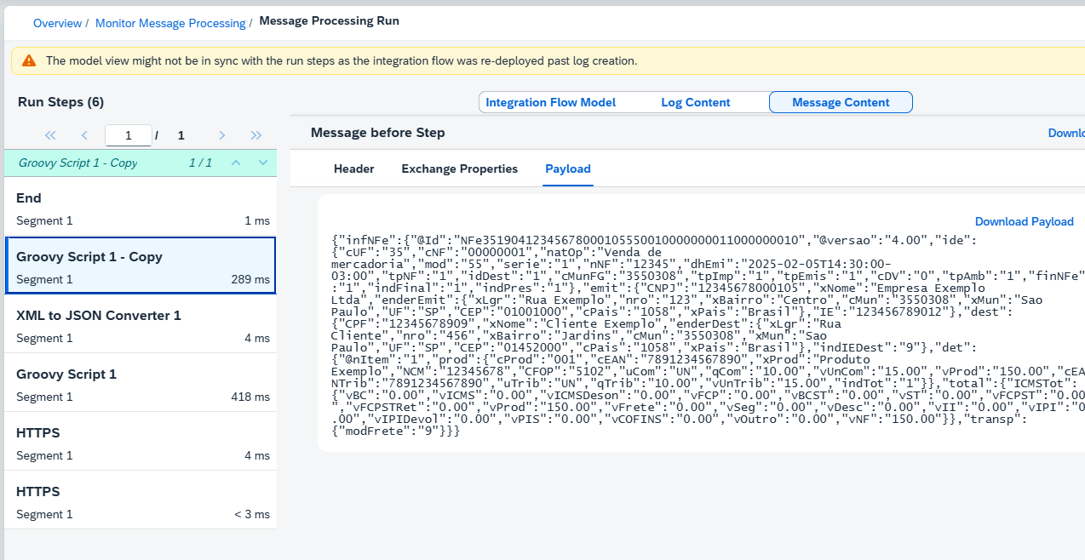

Again using groovy script to create easy logs upon conversion.